**For every purchase made, we will earn up to 40% back in rewards to help support our school!**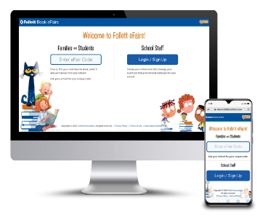

Supporting a love for reading is critical to student success. Explore our online book fair and help your child find their next favorite book.

Now everyone can participate! Encourage your child to create their online wish list and share with friends and family.

**efairs.follettbookfairs.com** 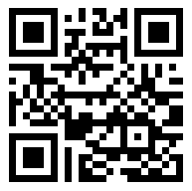

Our eFair code: **D1YDP**

Orders due by: **November 30th 2020**

Follett will ship your books to the school after our online is complete.

Follett will ship your books to the school after our eFair is complete.

**Special Events:**

**ICE CREAM PARTY** for the homeroom class with the most sales!!!

(SBDL will have a time to pick up ice cream if homeroom class wins)

**Monday, November 16th**-Book Fair Kick-off video

**Wednesday, November 18th** -Family Day- All purchasing shoppers names will be written down and placed in a drawing to receive a free book!

**Friday, November 20th**- Be the 100th shopper and win a trip to the School Store! ($5 value)

**Shop Your Fair Online – Anywhere, Anytime to support your Winston Willdcat from November 16th-November 30th!**

**Our school is hosting a Follett Book Fair Online!**

**For every purchase made, we will earn up to 40% back in rewards to help support our school!**